Project Title
(PLAGIARISM DETECTION ENGINE FOR ACADEMIC SUBMISSIONS)
Project Report submitted for the partial fulfilment of grade for the course

Data Structures and Algorithms -3 (25CS2103E)
in

A.Y. 2026-2027

Submitted by
P. Jahnavi (2520090012)
SRR. Keerthi (2520090150)

Team Number:
Section: 10

Under the guidance of

MS. Kanda Chandusha
Asst. Prof., CS&IT

Hyderabad-500090, Telangana, India.

K L (Deemed to be) University
DEPARTMENT OF COMPUTER SCIENCE ENGINEERING / COMPUTER SCIENCE AND INFORMATION TECHNOLOGY/ARTIFICIAL INTELLIGENCE & DATA SCIENCE



DECLARATION

The Mini Project Report entitled “Plagiarism Detection Engine for Academic Submissions” is a record of Bonafide work of Jahnavi – 2520090012., Keerthi – 2520090150. submitted in partial fulfillment for the award of B. Tech in Computer Science and Information Technology KL University. The results embodied in this report have not been copied from any other departments/University/Institute.

Jahnavi – 2520090012
Keerthi – 2520090150

K L (Deemed to be) University
DEPARTMENT OF COMPUTER SCIENCE ENGINEERING / COMPUTER SCIENCE AND INFORMATION TECHNOLOGY
CERTIFICATE

This is to certify that the mini project based report entitled “Plagiarism Detection Engine for Academic Submissions” is a Bonafide work done and submitted by Jahnavi – 2520090012., Keerthi – 2520090150. . in partial fulfillment of the requirements for the award of the degree of BACHELOR OF TECHNOLOGY in Computer Science and Information Technology, K L (Deemed to be University), during the academic year 2026-2027.

Signature of the Supervisor

Signature of the HOD Signature of the External Examiner

ACKNOWLEDGEMENT

The success in this project would not have been possible but for the timely help and guidance rendered by many people. Our wish to express my sincere thanks to all those who has assisted us in one way or the other for the completion of my project.

Our greatest appreciation to my guide, MS. Kanda Chandusha, Asst. Prof., CS&IT which cannot be expressed in words for his/her tremendous support, encouragement and guidance for this project.

We express our gratitude to Dr. Khaja Shareef (CSIT), Head of the Department for Computer Science and Information Technology for providing us with adequate facilities, ways and means by which we are able to complete this project-based Lab.

We thank all the members of teaching and non-teaching staff members, and also who have assisted me directly or indirectly for successful completion of this project. Finally, I sincerely thank my parents, friends and classmates for their kind help and cooperation during my work.

Jahnavi – 2520090012
Keerthi - 2520090150

TABLE OF CONTENTS

S.No. | Contents | Page no.
1. | Abstract | 6
2. | Introduction
3. | Literature survey
4. | Problem Statement and Objectives
5. | Hardware and Software requirements
6. | Implementation
7. | Results & Discussion
8. | Conclusion & Future Scope
9. | References

1.ABSTRACT

The Plagiarism Detection Engine for Academic Submissions is a software application designed to help educators identify copied or highly similar content in academic assignments and research papers. With the increasing availability of digital content, students can easily access and reuse information from different sources. Manually checking large numbers of submissions for plagiarism is time-consuming and may lead to errors.
The proposed system automates the plagiarism detection process by accepting academic documents as input and preprocessing the text before comparison. During preprocessing, unnecessary characters are removed and important words are extracted. The processed content is then converted into suitable patterns or features and compared with reference content using pattern-matching and similarity techniques. The system calculates a similarity score that indicates the degree of matching between the submitted document and the reference content.
The final result is presented in a clear report containing the similarity percentage and highlighted matching portions of text. This allows educators to quickly identify potentially copied content and make better decisions regarding academic originality. The system is intended to provide a fast, user-friendly, and efficient approach to plagiarism checking. Future improvements can include machine learning-based detection and online database integration for analysing larger collections of documents.
Team Members:
1. P. Jahnavi – 2520090012
2. SRR. Keerthi – 2520090150

- INTRODUCTION

Academic integrity is an important part of education and research. Students and researchers are expected to submit original work and properly acknowledge information obtained from other sources. However, the large amount of information available on the internet makes it easier to copy or reuse existing content.
Checking every assignment manually is difficult, especially when an educator has to evaluate a large number of submissions. Manual checking also requires considerable time and may not always identify similar content accurately.
The Plagiarism Detection Engine for Academic Submissions addresses this problem by automating the process of analysing academic documents. The system accepts the submitted text, performs preprocessing, extracts relevant features, and compares the processed content with reference content.
The main stages of the system are:
- Document Input
- Text Preprocessing
- Feature Extraction
- Similarity Comparison
- Similarity Report Generation
The system produces a similarity percentage and highlights matching content, making the results easier for educators to understand. The PPT describes the system as a fast and user-friendly application intended to reduce manual effort and support evidence-based decisions about originality.

- LITERATURE SURVEY
Plagiarism detection has been studied using different text-processing and similarity-analysis techniques. Traditional approaches mainly focus on detecting exact or near-exact matching content, while modern approaches attempt to identify similarities even when the wording has been changed.

3.1 TF-IDF
TF-IDF is a commonly used technique for representing the importance of words in a document. It gives higher importance to words that are frequent in a particular document but less common across the collection of documents. This representation can be used as a basis for comparing documents.

3.2 N-Gram Analysis
N-gram techniques divide text into sequences of words or characters. For example, a sentence can be divided into groups of consecutive words. Comparing these groups can help identify portions of text that are similar between documents.

3.3 Cosine Similarity
Cosine similarity measures the similarity between two documents represented as vectors. A higher cosine similarity value indicates that the documents have more similar content. 3.4 Jaccard Similarity
Jaccard similarity compares two sets and determines the proportion of common elements. In plagiarism detection, sets of words or features can be compared to identify common content.

3.5 NLP and Machine Learning
Recent plagiarism detection systems use Natural Language Processing and machine learning to identify paraphrased or semantically similar content. These approaches can detect similarities that cannot always be identified through direct word matching.
The proposed project is based on the foundations of preprocessing, pattern matching, and similarity measures, with future plans to incorporate machine learning and online corpus/database support.

- Problem Statement and Objectives

Problem Statement: Manual detection of plagiarism in academic submissions is time-consuming and difficult when handling a large number of documents.

Problem Description: Educators need an efficient way to compare student submissions with reference content and identify copied or highly similar text. Manual comparison can require significant effort and may not consistently identify all matching content.

Objectives:
The main objectives of the project are:
- To develop a system for detecting similarity in academic submissions.
- To automate the text comparison process.
- To preprocess submitted text before similarity analysis.
- To extract important words and features from documents.
- To compare documents using similarity and pattern-matching techniques.
- To calculate and display a similarity percentage.
- To highlight matching portions of text.
- To reduce the manual effort required for plagiarism checking.
- To provide a simple and user-friendly interface for analysing submissions.
- To provide a foundation for future machine-learning-based plagiarism detection.

- HARDWARE AND SOFTWARE REQUIREMENTS
Hardware Requirements:
- Processor- Intel Core i3
- RAM- 4 GB
- Storage- 500 MB for application logic
Software Requirements:
- Programming Language- Java
- Development Environment- VS Code
- Frontend- React.js
- Database- MySQL

- IMPLEMENTATION

Give here 3 to 4 modules code of your project
Pattern Search
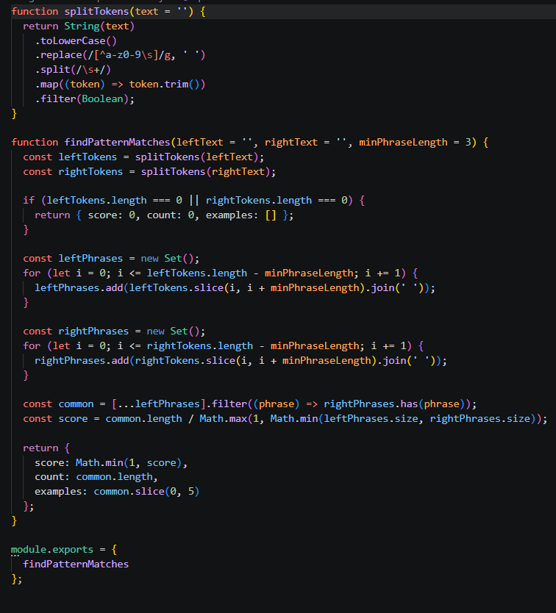

Flow analysis
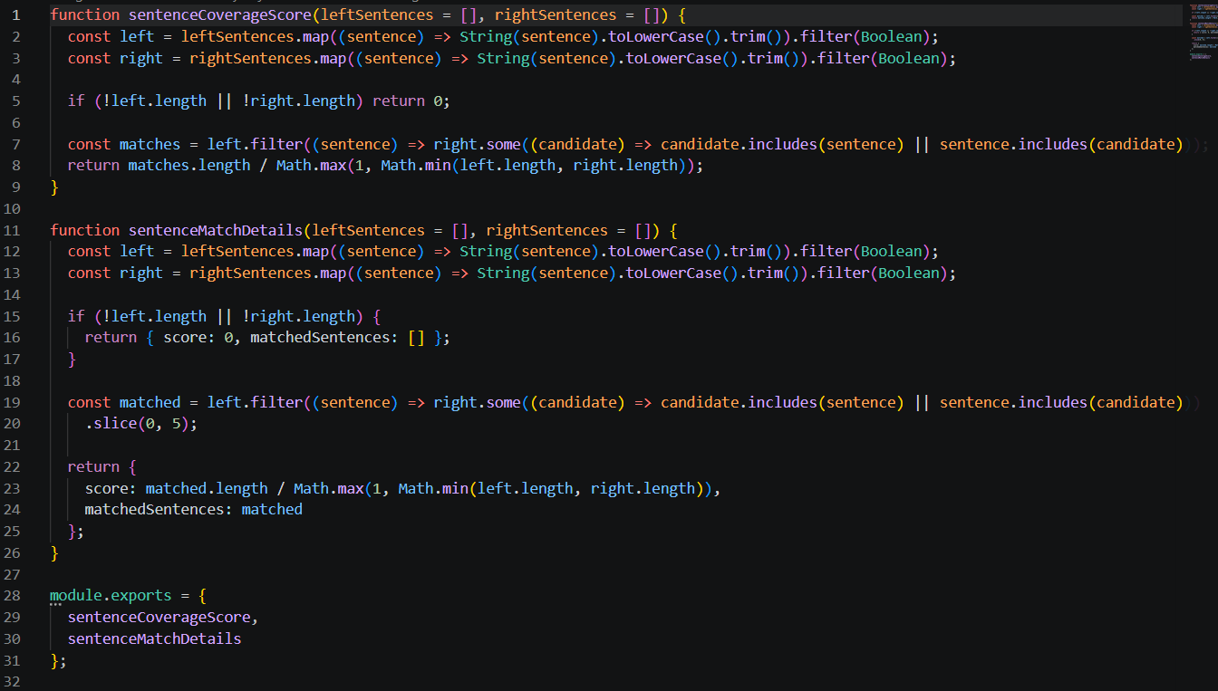
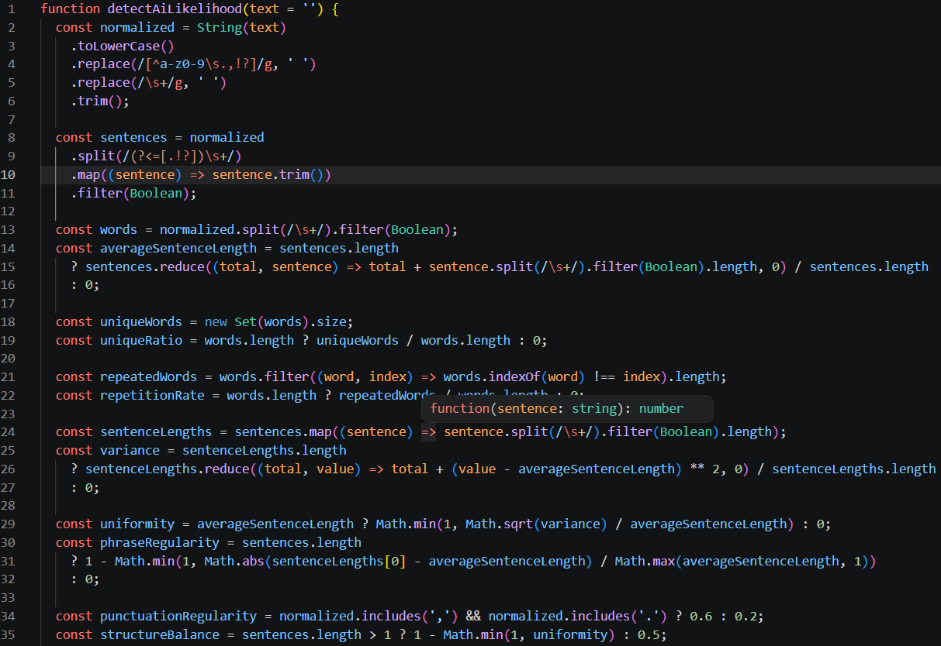
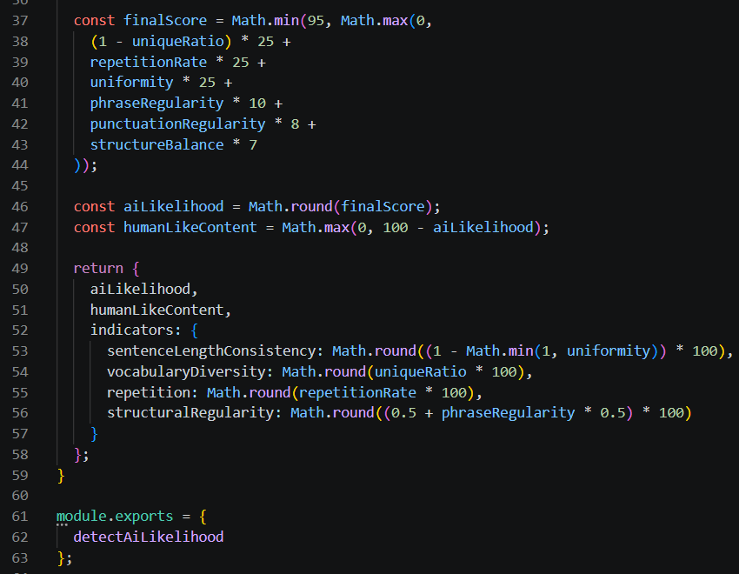

- RESULTS & DISCUSSION
Dashboard
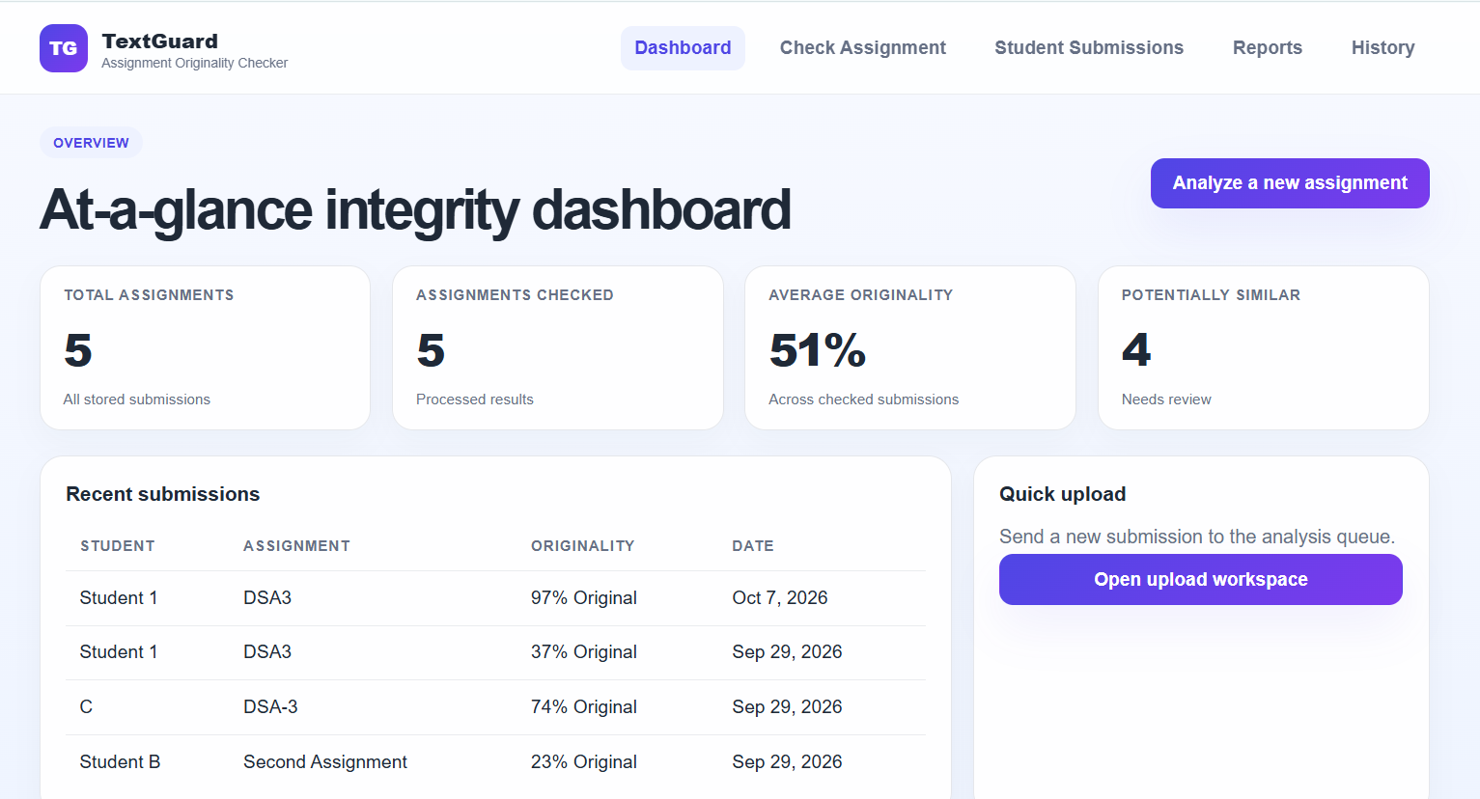
Check assignment
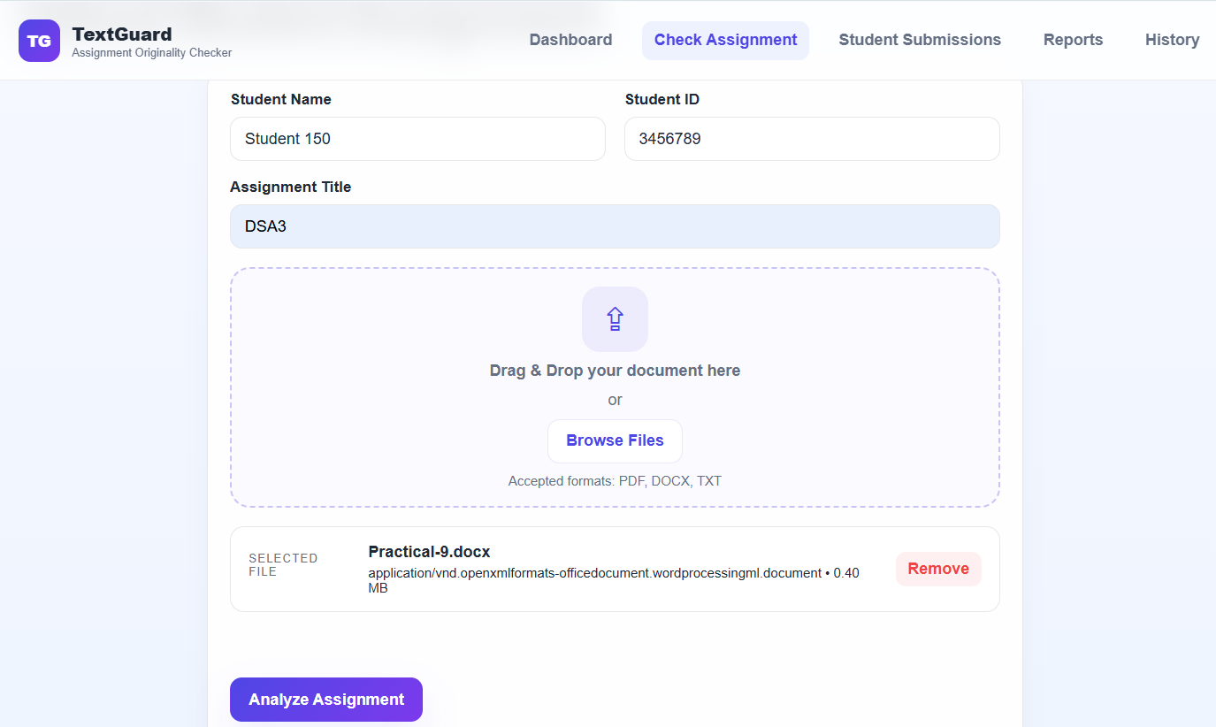
Assignment analysis
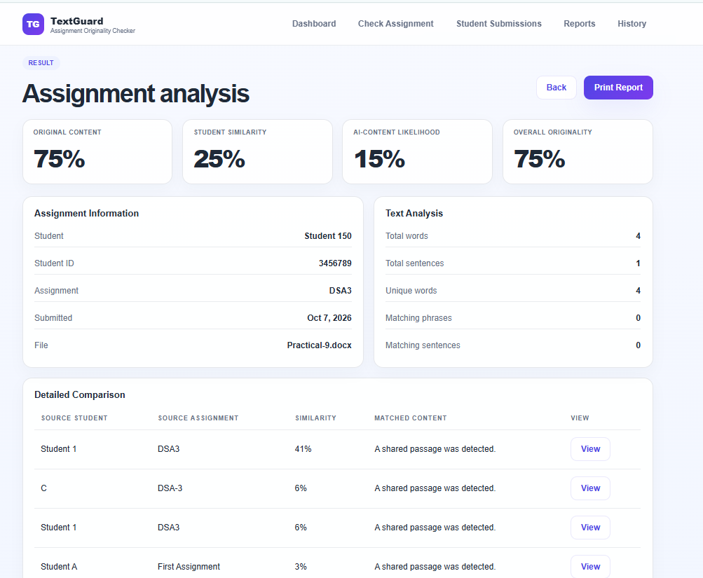
Student Submissions
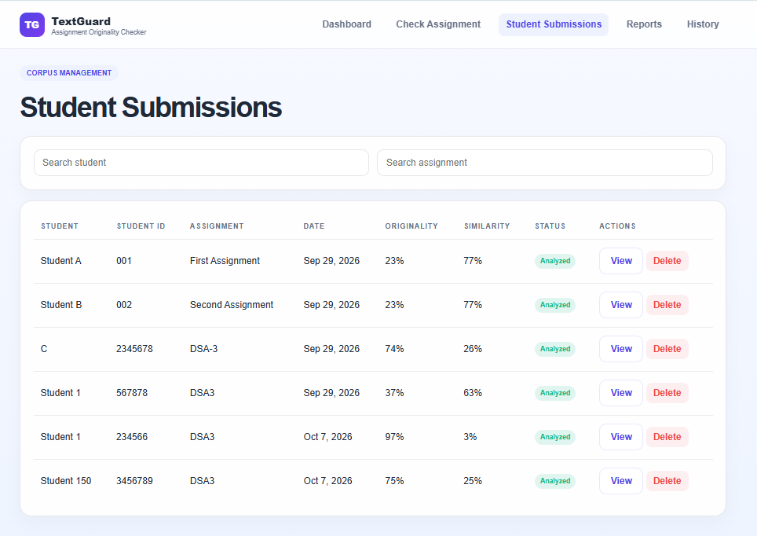
- CONCLUSION & FUTURE SCOPE
The Plagiarism Detection Engine for Academic Submissions provides an automated approach for identifying similar content in academic documents. The system addresses the limitations of manual plagiarism checking by processing submissions and comparing their content using text-processing, pattern-matching, and similarity techniques.
The major stages of the system include document input, text preprocessing, feature extraction, and similarity comparison. The final output provides a similarity score and highlights matching content, helping educators analyse submissions more efficiently.
The project demonstrates how data structures, algorithms, text processing, and similarity techniques can be applied to solve a practical academic problem. By reducing manual comparison effort, the system can support educators in maintaining academic integrity.

8.2 Future Scope
The project can be enhanced in several ways:

1. Machine Learning Integration
Machine learning techniques can be incorporated to improve plagiarism detection accuracy.

2. Semantic Similarity Detection
Future versions can detect paraphrased content where the same meaning is expressed using different words.

3. Online Database Support
The system can be connected to online databases and larger document collections for broader comparison.

4. Larger Document Processing
The application can be enhanced to process larger numbers of academic documents efficiently.

5. Improved Detection Accuracy
Advanced NLP techniques can be used to identify more complex forms of plagiarism.
These improvements are consistent with the future direction mentioned in the PPT, which proposes machine learning and online database support for improved detection accuracy across larger document collections.

- REFERENCES

1. Manning, C. D., Raghavan, P., and Schütze, H., Introduction to Information Retrieval, Cambridge University Press.
2. Jurafsky, D. and Martin, J. H., Speech and Language Processing, Natural Language Processing reference material.
3. Salton, G. and McGill, M. J., Introduction to Modern Information Retrieval, McGraw-Hill.
4. Reference materials on TF-IDF and document similarity.
5. Reference materials on N-gram-based text comparison.
6. Reference materials on Cosine Similarity for document comparison.
7. Reference materials on Jaccard Similarity and set-based comparison.
8. Reference materials on Natural Language Processing for plagiarism detection.
9. Research papers on machine-learning-based plagiarism detection.
10. Research papers on semantic similarity and academic plagiarism detection.

